

M.Sc. Computer Science and Engineering

Hypermedia Applications Project



Leoni Luca 10574709

Minotti Luca 10572239

Ratti Francesco 1111111111

www.reply.com

Usability Report

23rd March 2021

Version 1.0

**Abstract**

The aim of this Usability Report is to describe the results of the usability assessment carried out on the Reply website. Specifically, the analysis is performed using first the inspection method and then the user testing method.

The first method involves expert evaluators examining the application interface and evaluating its compliance with recognized usability principles called heuristics. Specifically, the analysis is conducted with reference to the Nielsen and MILE heuristics.

The user testing method instead consists of the data collection and observation of how some representatives of real users interact with the system. Its goal is to discover the actual difficulties encountered by users when interacting with the website and to obtain systematic feedback on its effectiveness and use.

# The Team

|  |  |
| --- | --- |
|  | Luca Leoni  MSc Computer Science and Engineering – EIT Digital Human Computer Interaction and Design  [luca3.leoni@mail.polimi.it](mailto:luca3.leoni@mail.polimi.it)  +39 3484124137 |
| Datei:User icon-cp.svg – Wikipedia | Luca Minotti  MSc Computer Science and Engineering  [luca2.minotti@mail.polimi.it](mailto:luca2.minotti@mail.polimi.it)  +39 3315228707 |
|  | Francesco Ratti  MSc Computer Science and Engineering  [francesco2.ratti@mail.polimi.it](mailto:francesco2.ratti@mail.polimi.it)  +39 |

**Contents**

1 Inspection 5

1.1 Inspection Design 5

1.1.1 Heuristics Definition 5

1.1.2 Metrics Definition 6

1.1.3 Evaluation Process Definition 7

1.2 Inspection Execution 7

2 Inspection Annex 11

2.1 Individual Inspection 1 11

2.2 Individual Inspection 2 17

2.3 Individual Inspection 3 23

3 User Testing 29

3.1 User Testing Design 29

3.1.1 User Profile Definition 29

3.1.2 Usability Variables Definition 29

3.1.3 Tasks Definition 29

3.1.4 Pilot Test 30

3.2 User Testing Execution 30

3.2.1 Execution 30

3.2.2 Data 30

3.2.3 Results 30

4 Final Conclusions 31

4.4.1 Comments on the results 31

4.4.2 Suggestion for Improvements 31

# 1 Inspection

Usability inspection is the generic name for a category of methods based on having expert evaluatorsanalytically examine UX-related aspects of an application. Typically, usability inspection is aimed at finding usability problems in a design, though some methods also address issues like the severity of the usability problems and the overall usability of an entire design. Here we focus on *Heuristic Evaluation*, an inspection method that involves evaluators examining the interface and judging its compliance with recognized usability principles (the "*heuristics"*).

## 1.1 Inspection Design

### 1.1.1 Heuristics Definition

This section precisely defines the heuristics used to conduct the inspection. Specifically, the analysis refers to the principles outlined by the *Nielsen* and *MILE* heuristics.

#### 1.1.1.1 Nielsen Heuristics

Jakob Nielsen’s heuristics are the most used usability heuristics for user interface design. Released in 1994, they define the following principles:

* **Visibility of system status:** the design should always keep users informed about what is going on, through appropriate feedback within a reasonable amount of time.
* **Match between system and the real world:** the system should speak the users’ language, with words, phrases and concepts familiar to the user, rather than system-oriented terms. Follow real-world conventions, making information appear in a natural and logical order.
* **User control and freedom:** users often choose system functions by mistake and will need a clearly marked “emergency exit” to leave the unwanted state without having to go through an extended dialogue. Support undo and redo.
* **Consistency and standards:** users should not have to wonder whether different words, situations, or actions mean the same thing. Follow “platform” conventions.
* **Error prevention:** even better than good error messages is a careful design which prevents a problem from occurring in the first place. Either eliminate error-prone conditions or check for them and present users with a confirmation option before they commit to the action.
* **Recognition rather than recall:** minimize the user’s memory load by making objects, actions, and options visible. The user should not have to remember information from one part of the dialogue to another. Instructions for use of the system should be visible or easily retrievable whenever appropriate.
* **Flexibility and efficiency of use:** accelerators - unseen by the novice user - may often speed up the interaction for the expert user such that the system can cater to both inexperienced and experienced users. Allow users to tailor frequent actions.
* **Aesthetic and minimalist design:** dialogues should not contain information which is irrelevant or rarely needed. Every extra unit of information in a dialogue competes with the relevant units of information and diminishes their relative visibility.
* **Help users recognize, diagnose and recover from errors:** error messages should be expressed in plain language (no codes), precisely indicate the problem, and constructively suggest a solution.
* **Help and documentation:** even though it is better if the system can be used without documentation, it may be necessary to provide help and documentation. Any such information should be easy to search, focused on the user’s task, list concrete steps to be carried out, and not be too large.

#### 1.1.1.2 MILE Heuristics

M**ILE is a scenario-based inspection technique that includes a large number of heuristics. For the execution of the analysis, only the following subset is considered:**

***Navigation heuristics***

* **Interaction consistency**: do pages of the same type have the same links and interaction capability?
* **Group navigation**: is it easy to navigate from and among groups of “items”? E.g., from the “list of items” of a group to its “members” (and the other way around); among different “groups”; among members of the same group (next/previous).
* **Structural Navigation**: is it easy to navigate among the “components” (parts) of a topic?
* **Semantic Navigation**: is it easy to navigate from a topic to a related one (in both directions)?
* **Landmarks**: are “landmarks” useful to reach the key parts of the web site?

***Content heuristics***

* **Information overload**: is the information in a page too much/too little?

***Presentation heuristics***

* **Text layout**: is the text readable? Is font size appropriate?
* **Interaction placeholders-semiotics**: are textual or visual labels of interactive elements “expressive”? i.e., do they reflect the meaning of the interaction and its effects? Are they consistent?
* **Interaction placeholders-consistency**: are textual or visual labels of interactive elements consistent in terms of wording, icon, position, etc.?
* **Spatial allocation**: is the on-screen allocation of contents and visual appropriate for their relevance? Are “semantically related” elements close and “semantically distant” element far away?
* **Consistency of Page Structure**: do pages of the same type have the same layout (same visual properties of each component and similar organization and layout of the various elements)?

### 1.1.2 Metrics Definition

The metrics used for the inspection are defined as follows:

|  |  |
| --- | --- |
| **Metric** | **Description** |
| N/A | Not applicable |
| 0 | The heuristic is NOT satisfied; severe violations have been detected |
| 1 | The heuristic is partly satisfied, website is structured adequately according to the heuristics, but they are implemented in the wrong way |
| 2 | The heuristic is partly satisfied but it can be massively improved |
| 3 | The heuristic is satisfied but it can be improved |
| 4 | The heuristic is almost fully satisfied but there are some imperfections |
| 5 | The heuristic is FULLY satisfied; no violations has been detected |

### 1.1.3 Evaluation Process Definition

The inspection is carried out as specified in this section. First, each expert evaluator individually carries out an in-depth analysis of the website by referring to the previously defined heuristics and metrics. By doing this, a time of at least 15 minutes will be dedicated to each of the main sections. All the detailed reports of these analyses are given in the *Inspection Annex**.* The results are then discussed among all the inspectors to reach a shared agreement on comments and scores.

The usability evaluation is carried out on the entire website, with particular attention to the following pages and sections:

* Homepage
* Topics Section
* Industries Section
* Careers Page (Join)
* About Page
* Investors Page
* Newsroom Page
* Personal Profile Page
* Search Page

## 1.2 Inspection Execution

This section reports the results of the inspection process defined above with the precise details of any identified problem.

|  |  |  |
| --- | --- | --- |
| **Heuristic Type** | **Heuristic** | **Overall Score** |
| Nielsen | Visibility of system status |  |

Bla bla bla

Images

|  |  |  |
| --- | --- | --- |
| **Heuristic Type** | **Heuristic** | **Overall Score** |
| Nielsen | Match between system and the real world |  |

Bla bla bla

Images

|  |  |  |
| --- | --- | --- |
| **Heuristic Type** | **Heuristic** | **Overall Score** |
| Nielsen | User control and freedom |  |

Bla bla bla

Images

|  |  |  |
| --- | --- | --- |
| **Heuristic Type** | **Heuristic** | **Overall Score** |
| Nielsen | Consistency and standards |  |

Bla bla bla

Images

|  |  |  |
| --- | --- | --- |
| **Heuristic Type** | **Heuristic** | **Overall Score** |
| Nielsen | Error prevention |  |

Bla bla bla

Images

|  |  |  |
| --- | --- | --- |
| **Heuristic Type** | **Heuristic** | **Overall Score** |
| Nielsen | Recognition rather than recall |  |

Bla bla bla

Images

|  |  |  |
| --- | --- | --- |
| **Heuristic Type** | **Heuristic** | **Overall Score** |
| Nielsen | Flexibility and efficiency of use |  |

Bla bla bla

Images

|  |  |  |
| --- | --- | --- |
| **Heuristic Type** | **Heuristic** | **Overall Score** |
| Nielsen | Aesthetic and minimalist design |  |

Bla bla bla

Images

|  |  |  |
| --- | --- | --- |
| **Heuristic Type** | **Heuristic** | **Overall Score** |
| Nielsen | Help users recognize, diagnose and recover from errors |  |

Bla bla bla

Images

|  |  |  |
| --- | --- | --- |
| **Heuristic Type** | **Heuristic** | **Overall Score** |
| Nielsen | Help and documentation | N/A |

This heuristic does not apply to the system under consideration.

|  |  |  |
| --- | --- | --- |
| **Heuristic Type** | **Heuristic** | **Overall Score** |
| MILE Navigation | Interaction consistency |  |

Bla bla bla

Images

|  |  |  |
| --- | --- | --- |
| **Heuristic Type** | **Heuristic** | **Overall Score** |
| MILE Navigation | Group navigation |  |

Bla bla bla

Images

|  |  |  |
| --- | --- | --- |
| **Heuristic Type** | **Heuristic** | **Overall Score** |
| MILE Navigation | Structural navigation |  |

Bla bla bla

Images

|  |  |  |
| --- | --- | --- |
| **Heuristic Type** | **Heuristic** | **Overall Score** |
| MILE Navigation | Semantic navigation |  |

Bla bla bla

Images

|  |  |  |
| --- | --- | --- |
| **Heuristic Type** | **Heuristic** | **Overall Score** |
| MILE Navigation | Landmarks |  |

Bla bla bla

Images

|  |  |  |
| --- | --- | --- |
| **Heuristic Type** | **Heuristic** | **Overall Score** |
| MILE Content | Information overload |  |

Bla bla bla

Images

|  |  |  |
| --- | --- | --- |
| **Heuristic Type** | **Heuristic** | **Overall Score** |
| MILE Presentation | Text layout |  |

Bla bla bla

Images

|  |  |  |
| --- | --- | --- |
| **Heuristic Type** | **Heuristic** | **Overall Score** |
| MILE Presentation | Interaction placeholders-semiotics |  |

Bla bla bla

Images

|  |  |  |
| --- | --- | --- |
| **Heuristic Type** | **Heuristic** | **Overall Score** |
| MILE Presentation | Interaction placeholders-consistency |  |

Bla bla bla

Images

|  |  |  |
| --- | --- | --- |
| **Heuristic Type** | **Heuristic** | **Overall Score** |
| MILE Presentation | Spatial allocation |  |

Bla bla bla

Images

|  |  |  |
| --- | --- | --- |
| **Heuristic Type** | **Heuristic** | **Overall Score** |
| MILE Presentation | Consistency of Page Structure |  |

Bla bla bla

Images

# 2 Inspection Annex

This chapter contains the complete individual reports of the inspections on the usability of the Reply website.

## 2.1 Individual Inspection 1

|  |  |  |  |  |
| --- | --- | --- | --- | --- |
| **Inspector:** Luca Leoni | | | | |
| **Heuristic Type** | **Heuristic** | **Score** | **Comment** | **Reference** |
| Nielsen | Visibility of system status | 1 | Despite the website retains the information about the status, the bread crumbs is badly implemented. The user is not aware of the presence of it. Indeed, it is not clearly shown as a status bar. A kind of Location Based Bread Crumbs is implemented, but not in an intuitive way. | Screenshot 1. 1 |



Screenshot 1. 1

|  |  |  |  |  |
| --- | --- | --- | --- | --- |
| **Heuristic Type** | **Heuristic** | **Score** | **Comment** | **Reference** |
| Nielsen | Match between system and the real world | 4 | The only problem is related to the partial translation of the principal labels. In fact, the main labels are only in English, so, they could not appear natural and logical to the users. | Screenshot 1. 2 |



Screenshot 1. 2

|  |  |  |  |  |
| --- | --- | --- | --- | --- |
| **Heuristic Type** | **Heuristic** | **Score** | **Comment** | **Reference** |
| Nielsen | User control and freedom | 4 | In the majority of the cases, you can at most perform 3 steps. From the Homepage to a specific showcase (you can go back through the x button) and from there to a specific page. In this case we have to differentiate the case in which a new panel is opened and the case in which appears a window.  PANEL: you can go back simply by closing the panel.  WINDOW: a x button will show and through that you can return to the previous page. |  |
| Nielsen | Consistency and standards | 5 | The essential standards are respected, such as login button, search box, exit button and share icons. | Screenshot 1. 3 |

Screenshot 1. 3

|  |  |  |  |  |
| --- | --- | --- | --- | --- |
| **Heuristic Type** | **Heuristic** | **Score** | **Comment** | **Reference** |
| Nielsen | Error prevention | 3 | The system presents some weaknesses. For instance, when a new user performs the Registration process, only after confirming the request, the system checks if the rules concerning password or email are followed. | Screenshot 1. 4 |

Screenshot 1. 4

|  |  |  |  |  |
| --- | --- | --- | --- | --- |
| **Heuristic Type** | **Heuristic** | **Score** | **Comment** | **Reference** |
| Nielsen | Recognition rather than recall | 2 | The system does not provide any suggestions when a user tries to search something. Despite that, in the Webinar section, it has been implemented a live filtering search box (every time the user types a letter, the system checks and shows only the matching results). | Screenshot 1. 5 |

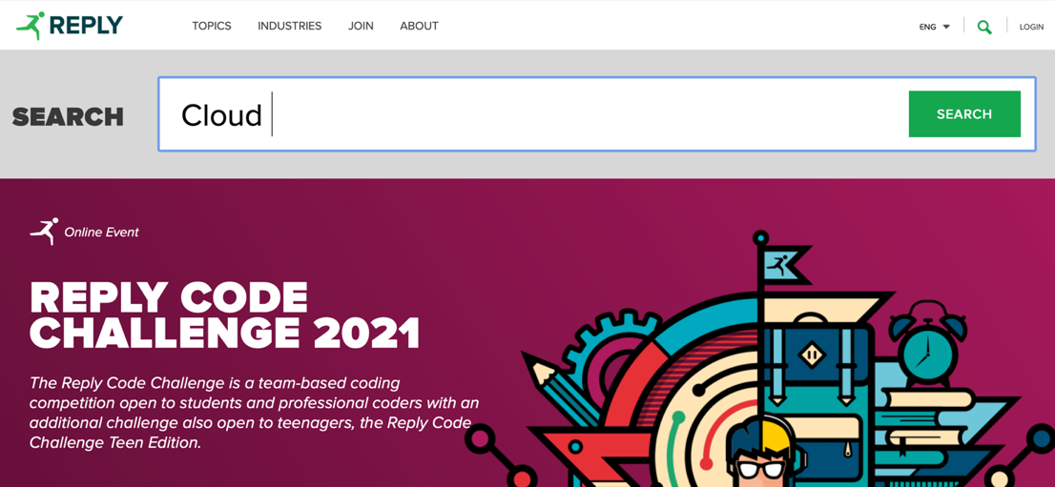

Screenshot 1. 5

|  |  |  |  |  |
| --- | --- | --- | --- | --- |
| **Heuristic Type** | **Heuristic** | **Score** | **Comment** | **Reference** |
| Nielsen | Flexibility and efficiency of use | 4 | The landmarks are always available in each page of the website, but the search button disappear when the user enters the Webinar section |  |
| Nielsen | Aesthetic and minimalist design | 0 | The whole website is crowded of information. There are too many subcategories in each section. The Homepage acts as a showcase with all the articles of the website. | Screenshot 1. 6 |

Screenshot 1. 6

|  |  |  |  |  |
| --- | --- | --- | --- | --- |
| **Heuristic Type** | **Heuristic** | **Score** | **Comment** | **Reference** |
| Nielsen | Help users recognize, diagnose and recover from errors | 1 | The heuristic is not satisfied in several cases. If a user searches through the search box and commits a typo the system is able to detect it, but it does not show the correct answers. Also, in the Webinar section happens the same. During the login process, if a user writes the wrong email or password, the system notifies the user with a generic error message. | Screenshot 1. 7  Screenshot 1. 8 |

Screenshot 1. 7

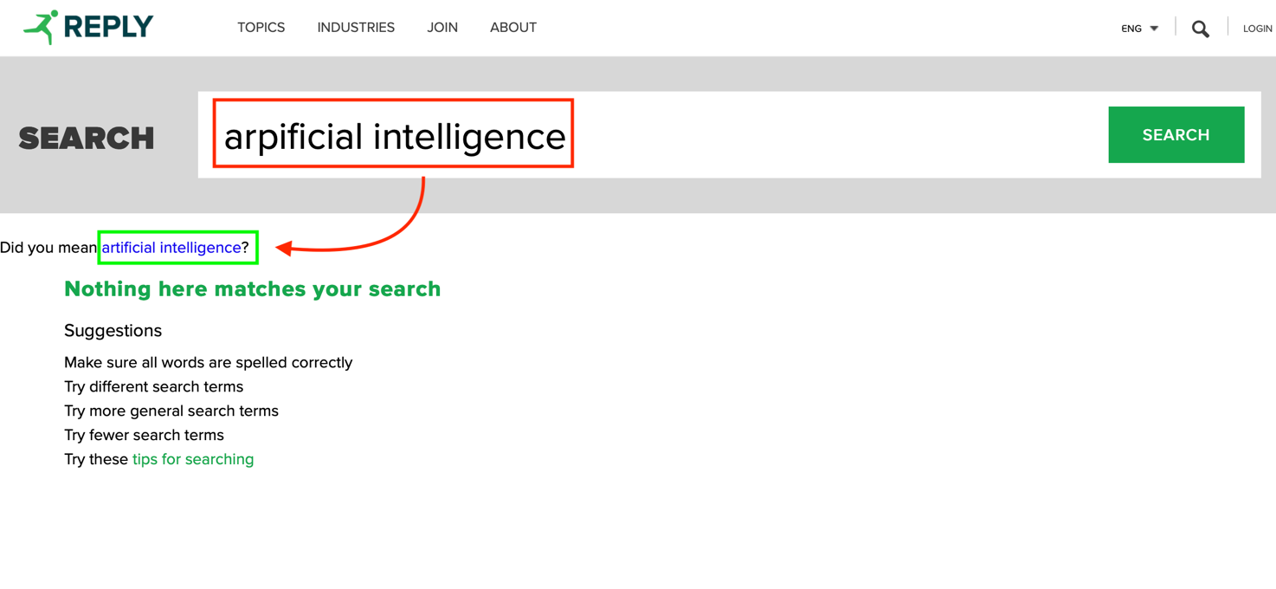

Screenshot 1. 8

|  |  |  |  |  |
| --- | --- | --- | --- | --- |
| **Heuristic Type** | **Heuristic** | **Score** | **Comment** | **Reference** |
| Nielsen | Help and documentation | N/A | - |  |
| MILE Navigation | Interaction consistency | 5 | The steps to be followed are always the same. |  |
|  | Group navigation | 0 | The flow is not stable. Indeed, due to the leak of bread crumbs, the user cannot navigate through the different pages without restarting from scratch. | Screenshot 1. 9 |

Screenshot 1. 9

|  |  |  |  |  |
| --- | --- | --- | --- | --- |
| **Heuristic Type** | **Heuristic** | **Score** | **Comment** | **Reference** |
| MILE Navigation | Structural Navigation | 0 | As said for the previous heuristic, the main problem relies on the absence of a proper bread crumb. |  |
| MILE Navigation | Semantic Navigation | N/A | Due to the fact that in the majority of the cases, the website opens a new panel. |  |
| MILE Navigation | Landmarks | 4 | The landmarks are always available. Despite that, they are full of information and sometimes the user does not know in advance exactly where he has to go to find an information. |  |
| MILE Content | Information overload | 0 | The Homepage is full of information. It contains all the articles posted on the website. | Screenshot 1. 10 |

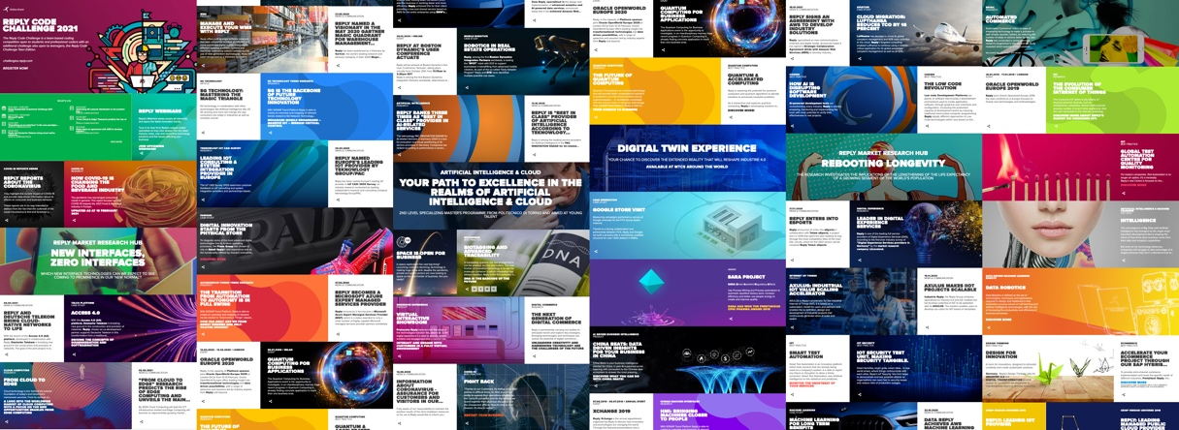

Screenshot 1. 10

|  |  |  |  |  |
| --- | --- | --- | --- | --- |
| **Heuristic Type** | **Heuristic** | **Score** | **Comment** | **Reference** |
| MILE Presentation | Text layout | 5 | Despite that in many cases the website uses an image as a background, the text is readable. | Screenshot 1. 11 |



Screenshot 1. 11

|  |  |  |  |  |  |
| --- | --- | --- | --- | --- | --- |
| **Heuristic Type** | **Heuristic** | **Score** | | **Comment** | **Reference** |
| MILE Presentation | Interaction placeholders-semiotics | 5 | | - |  |
| MILE Presentation | Spatial allocation | | 5 | - |  |
| MILE Presentation | Consistency of Page Structure | 4 | | The heuristic is not satisfied just in the About section. Indeed, sometimes a new page appears as a pop-up window, while sometimes it is opened in a new panel. | [URL](https://www.reply.com/en/investors/) |

## 2.2 Individual Inspection 2

|  |  |  |  |  |
| --- | --- | --- | --- | --- |
| **Inspector:** Luca Minotti | | | | |
| **Heuristic Type** | **Heuristic** | **Score** | **Comment** | **References** |
| Nielsen | Visibility of system status | 2 | Bread crumbs do not clearly show where the user is in the website hierarchy. Their implementation is extremely counterintuitive. | Screenshot 2. 1 |

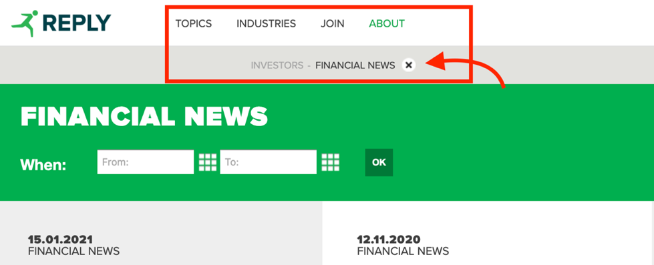

Screenshot 2. 1: <https://www.reply.com/en/investors/news>

|  |  |  |  |  |
| --- | --- | --- | --- | --- |
| **Heuristic Type** | **Heuristic** | **Score** | **Comment** | **References** |
| Nielsen | Match between system and the real world | 3 | The system mainly uses words familiar to the user. However, several pages of the website as well as the navigation bar, the search bar and error messages are shown in English regardless of the language chosen by the user. | Screenshot 2. 2  Screenshot 2. 3 |

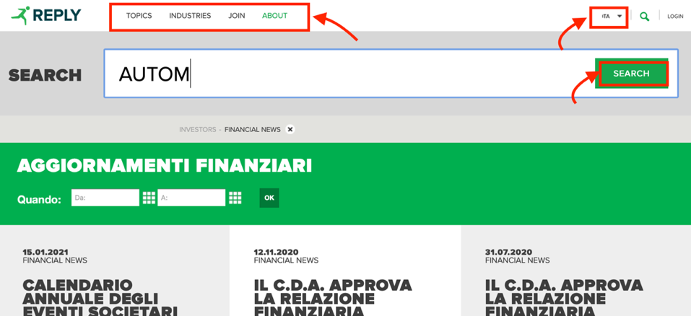

Screenshot 2. 2: <https://www.reply.com/it/investors/notizie>

Screenshot 2. 3: <https://www.reply.com/it/filenotfound>

|  |  |  |  |  |
| --- | --- | --- | --- | --- |
| **Heuristic Type** | **Heuristic** | **Score** | **Comment** | **References** |
| Nielsen | User control and freedom | 5 | Where applicable, the user always has the possibility to modify a previous choice without having to start over. For example, when filtering the upcoming events, the user always has the possibility to modify a wrong choice of the date range. | Screenshot 2. 4 |

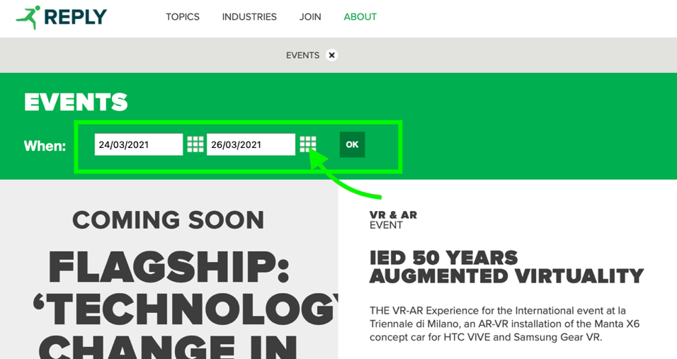

Screenshot 2. 4: <https://www.reply.com/en/newsroom/events>

|  |  |  |  |  |
| --- | --- | --- | --- | --- |
| **Heuristic Type** | **Heuristic** | **Score** | **Comment** | **References** |
| Nielsen | Consistency and standards | 5 | The website is consistent in the terminologies used and adheres to design standards (e.g., login button at the top right, standard icons for searching, sharing and closing pop-up windows, burger menu for the mobile version) | Screenshot 2. 5 |

Screenshot 2. 5: <https://www.reply.com>

|  |  |  |  |  |
| --- | --- | --- | --- | --- |
| **Heuristic Type** | **Heuristic** | **Score** | **Comment** | **References** |
| Nielsen | Error prevention | 3 | The system correctly requests confirmation to carry out some operations that the user may incorrectly select, such as deleting the account. However, sections such as the registration one need significant improvements (here the user has no way of knowing the password security requirements before submitting the form). | Screenshot 2. 6  Screenshot 2. 7 |

Screenshot 2. 6: <https://www.reply.com/en/userprofile>

Screenshot 2. 7: <https://www.reply.com/en/register>

|  |  |  |  |  |
| --- | --- | --- | --- | --- |
| **Heuristic Type** | **Heuristic** | **Score** | **Comment** | **References** |
| Nielsen | Recognition rather than recall | 2 | The system does not provide any suggestions for filling in some fields during registration or when searching the site using the appropriate function. | - |
| Nielsen | Flexibility and efficiency of use | 5 | Heuristics satisfied when applicable. For example, the system allows the insertion of dates both through the text boxes (inexperienced user) and through the calendar icon (accelerator for expert user). | Screenshot 2. 8 |

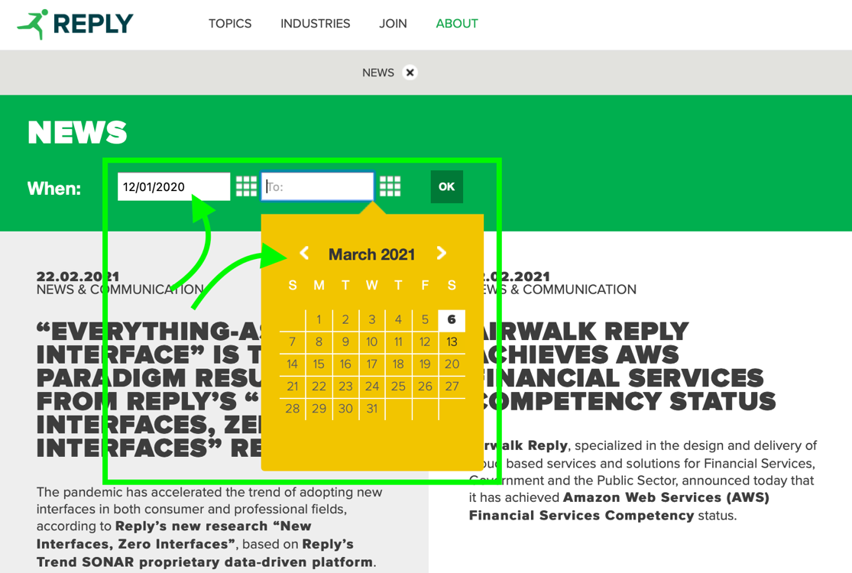

Screenshot 2. 8: <https://www.reply.com/en/newsroom/news>

|  |  |  |  |  |
| --- | --- | --- | --- | --- |
| **Heuristic Type** | **Heuristic** | **Score** | **Comment** | **References** |
| Nielsen | Aesthetic and minimalist design | 2 | The homepage shows too much information making it difficult to find what you are interested in. Even the menu items (e.g., Topics) in the top bar are too many and are not organized into further sub-categories, causing confusion. | Screenshot 2. 9 |

Screenshot 2. 9: <https://www.reply.com/en/>

|  |  |  |  |  |
| --- | --- | --- | --- | --- |
| **Heuristic Type** | **Heuristic** | **Score** | **Comment** | **References** |
| Nielsen | Help users recognize, diagnose and recover from errors | 1 | Some errors such as the page not found error are accompanied by a short explanation message, while others simply show a code and give no indication of what went wrong. | Screenshot 2. 10 |

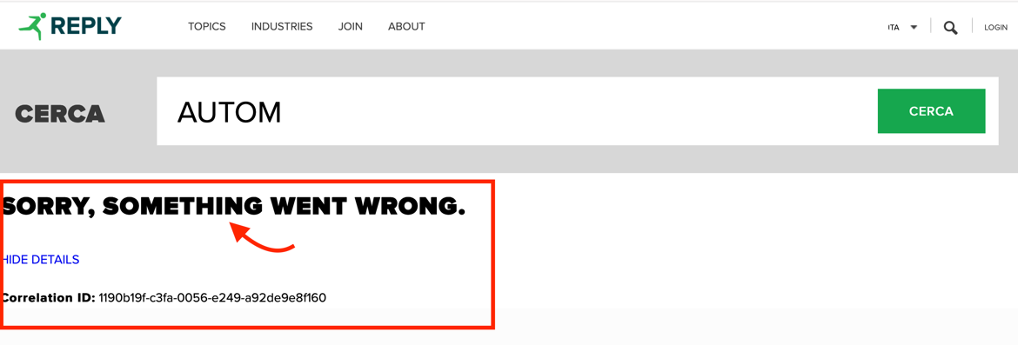

Screenshot 2. 10: <https://www.reply.com/en/search>

|  |  |  |  |  |
| --- | --- | --- | --- | --- |
| **Heuristic Type** | **Heuristic** | **Score** | **Comment** | **References** |
| Nielsen | Help and documentation | N/A | - | - |
| MILE Navigation | Interaction consistency | 5 | No anomaly detected. | - |
| MILE Navigation | Group navigation | 0 | To move from one article to another or from one topic to another, the user must start over, making navigation difficult. Bread crumbs also do not provide any useful action to go back. | Screenshot 2. 11 |

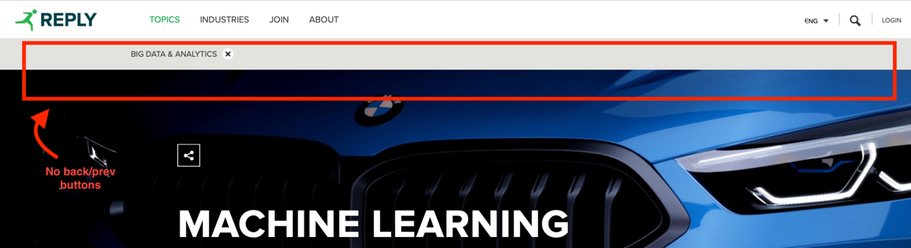

Screenshot 2. 11: <https://www.reply.com/en/topics/>

|  |  |  |  |  |
| --- | --- | --- | --- | --- |
| **Heuristic Type** | **Heuristic** | **Score** | **Comment** | **References** |
| MILE Navigation | Structural Navigation | 3 | The problems are concentrated in the homepage of the website and in the Investors section: too many components make it difficult to navigate between them and easily find what you are looking for. | - |

|  |  |  |  |  |
| --- | --- | --- | --- | --- |
| **Heuristic Type** | **Heuristic** | **Score** | **Comment** | **References** |
| MILE Navigation | Semantic Navigation | N/A | - | - |
| MILE Navigation | Landmarks | 5 | Landmarks correctly provide useful access points to the main components of the website. | - |
| MILE Content | Information overload | 1 | The homepage and navigation drop-down menus show too much information making it easy to get lost. The information load is instead balanced in the various subsections (e.g., Topic). | Screenshot 2. 12 |

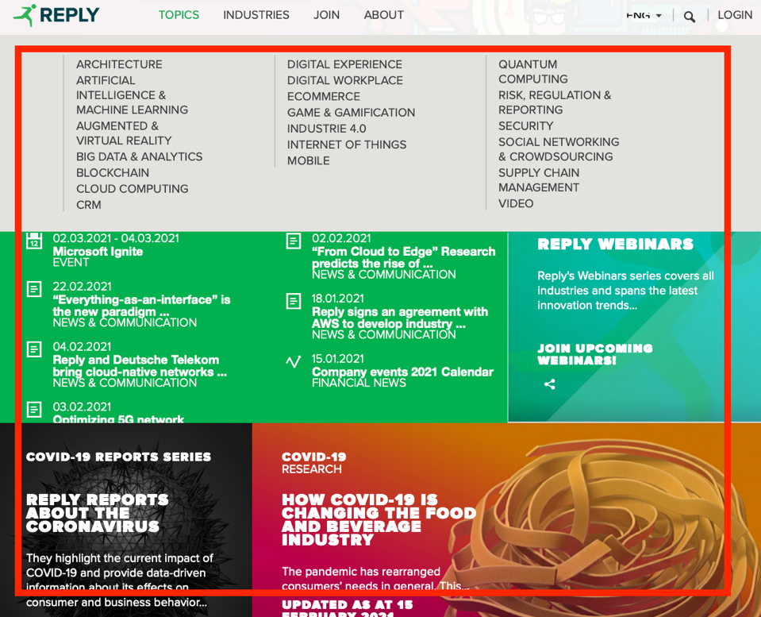

Screenshot 2. 12: <https://www.reply.com>

|  |  |  |  |  |
| --- | --- | --- | --- | --- |
| **Heuristic Type** | **Heuristic** | **Score** | **Comment** | **References** |
| MILE Presentation | Text layout | 5 | The text is always clearly readable. | - |
| MILE Presentation | Interaction placeholders-semiotics | 5 | No anomaly detected. | - |
| MILE Presentation | Spatial allocation | 5 | No anomaly detected: good spatial allocation. | - |
| MILE Presentation | Consistency of Page Structure | 4 | Almost all pages on the website have the same basic structure. Only some of them, in the about section, have different structures (some are shown as pop-ups, others as pages) despite dealing with the same type of information. | - |

## 2.3 Individual Inspection 3

|  |  |  |  |  |
| --- | --- | --- | --- | --- |
| **Inspector:** Francesco Ratti | | | | |
| **URL** | **Heuristic Type** | **Heuristic** | **Score** | **Comment** |
|  | Nielsen | 1. Visibility of system status | 1 | Bread crump is visible in some pages, so user should be able to know where he/she is. The problem here is that the bread crump is not effective: in any section it shows just the current section name and an X. *Screenshot 3.1* X meaning isn’t so clear.  Moreover, when opening an article which takes us outside of the topic page, the bread crump disappears. *Screenshot 3.2, 3.3*  In my opinion, bread crump should be fixed to the top of the viewport, so the user has not to scrool to the top of the page.  /*in this case and, most of all, in subsections (like CRM one, reported in the screenshot which is a subsection of the “Machine Learning Topic”, no hierarchy is reported, showing just the current page title, giving no “spatial” idea to the user.*/ |



Screenshot 3.1



Screenshot 3.2

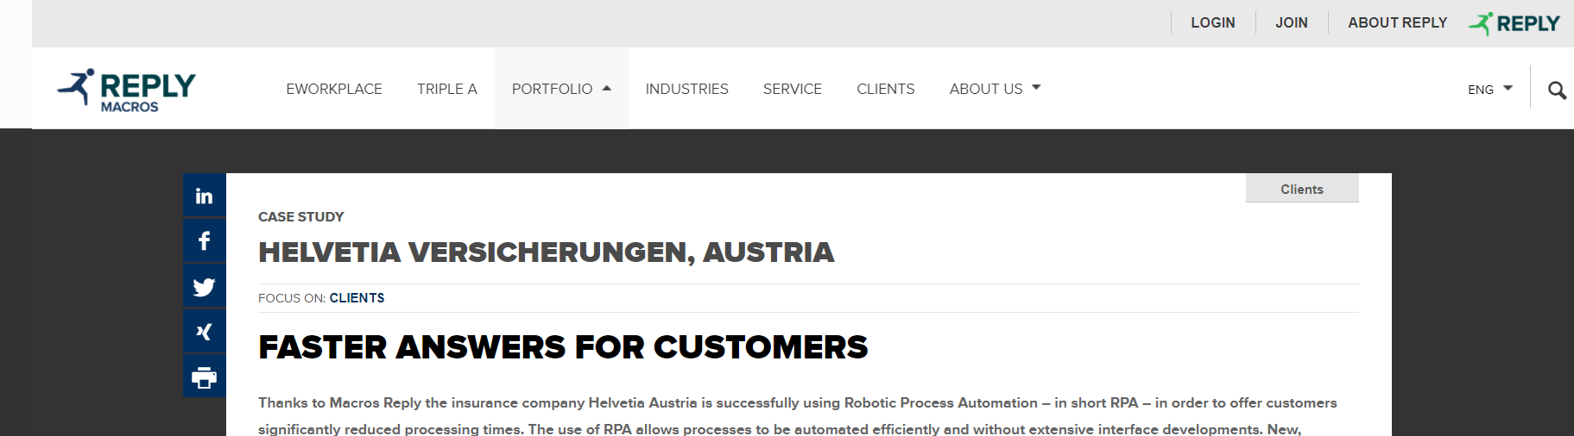

Screenshot 3.3

|  |  |  |  |  |
| --- | --- | --- | --- | --- |
|  |  | 1. Match between system and the real world | 1(2?) | Part of website is in destination language and part is still in English. Screenshot 3.4 |



Screenshot 3.4

|  |  |  |  |  |
| --- | --- | --- | --- | --- |
|  |  | H3. User control and freedom | 5 | User is freely able to navigate the site and leave the current page by means of the persistent header on top of the viewport. Screenshot 3.5 |



Screenshot 3.5

|  |  |  |  |  |
| --- | --- | --- | --- | --- |
|  |  | H4. Consistency and standards | 5 | Sharing icon coherent to standard ones (material design)  Lens icon to search which is a standard and arrow to indicate a dropdown menu when choosing language. *Screenshot 3.6*  Plus (*screenshot 3.7*), minus to show more or less informations and social network logos are consistent. *Screenshot 3.8* |



Screenshot 3.6

Screenshot 3.7



Screenshot 3.8

|  |  |  |  |  |
| --- | --- | --- | --- | --- |
|  |  | H5 Error prevention | 5 | Few simple items which allow to navigate: upper bar menu voices (*Screenshot 3.5*) and articles titles in the homepage topics: it is unambiguous that clicking on a title will lead the user to read the related article. |

|  |  |  |  |  |
| --- | --- | --- | --- | --- |
|  |  | Recognition rather than recall | 2 | No suggestion when typing, this is a major drawback in my opinion since user may don’t know precisely what to search on the website (he/she doesn’t know what kind of threads are there). *Screenshot 3.9*  If the user commits a typo the system suggests the right search key, which is a great thing. *Screenshot 3.10* |

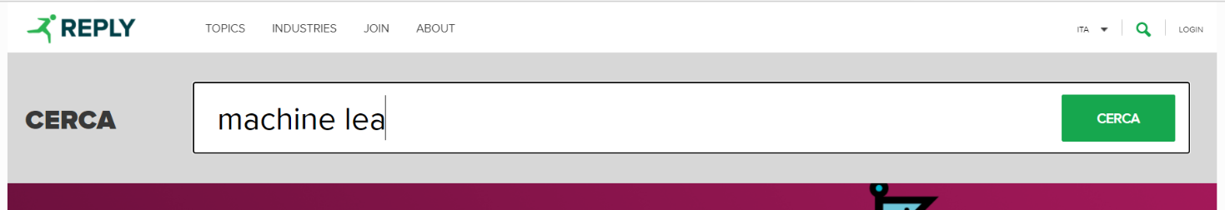

Screenshot 3.9

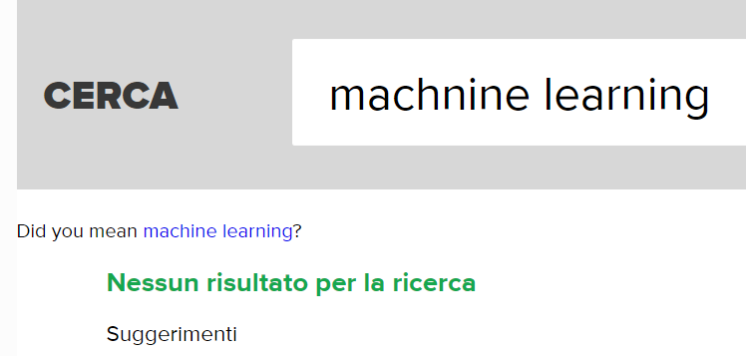

Screenshot 3.10

|  |  |  |  |  |
| --- | --- | --- | --- | --- |
|  |  | Flexibility and efficiency of use | 2 | Navigation through topics in the top bar menu is confusionary: topics are listed and no categorisation or grouping between them. *Screenshot 3.11*  No accelerators but may be not needed |



Screenshot 3.11

|  |  |  |  |  |
| --- | --- | --- | --- | --- |
|  |  | 1. Aesthetic and minimalist design | 2 | Too many items (articles) with long descriptions in a single page.  Everything is a bit “compacted” leading to a little information explosion. *Screenshot 3.12*  Otherwise good design. |

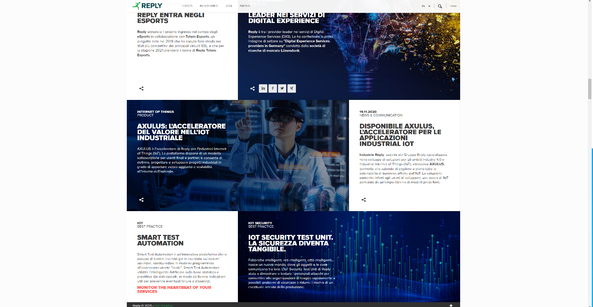

Screenshot 3.12

|  |  |  |  |  |
| --- | --- | --- | --- | --- |
|  |  | Help users recognize, diagnose and recover from errors | 2 | Login error message is expressed in plain language but does not suggest a solution neither offers a way to go back, an “insulated” page which is completely different from the previous one appears leading to disorientation in the user.  *Screenshot 3.13* |

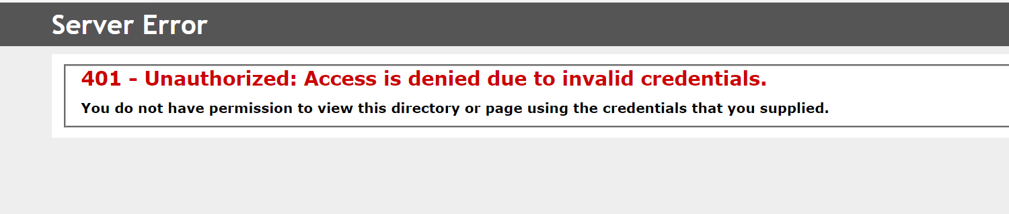

Screenshot 3.13

|  |  |  |  |  |
| --- | --- | --- | --- | --- |
|  |  | Help and documentation | NA |  |

# 3 User Testing

User testing consists of the data collection and observation of how some representatives of real users interact with the system. User behaviours are observed, recorded and then analysed.

Its goal is to discover the actual difficulties encountered by users when interacting with the website and to obtain systematic feedback on its effectiveness and use.

## 3.1 User Testing Design

Due to the pandemic, the test has been designed according to some constraints. Fortunately, the situation had no impact on the definition of the User Profile and the definition of the Tasks. The test will be held completely remotely, sharing the screen and recording the session. Since it is not possible to act like a proper moderator, user testers are encouraged to embrace the *Thinking Aloud* technique.

*Think Aloud* is a method invented by psychologist Édouard Claparède, which consists in externalise by voice what users think and plan during task execution.

### 3.1.1 User Profile Definition

### 3.1.2 Usability Variables Definition

Some variables have been chosen to be measured during the execution of the tasks and with a subsequent survey for the testers. The usability variables include both quantitative and qualitative indicators and are reported in the following table.

|  |  |  |
| --- | --- | --- |
| **Usability Variable** | | **Description** |
| *V1* | *Effectiveness* | Task success rate |
| *V2* | *Efficiency* | Time needed to complete the task |
| *V3* | *Errors* | Wrong paths or actions while completing the task |
| *V4* | *Satisfaction* | Users’ feelings about the navigation experience |
| *V5* | *Disorientation* | Difficulty in understanding how to move between the shown contents |
| *V6* | *Wandering periods* | Difficulty to realize the next steps |
| *V7* | *Confidence with the design* | Difficulty in understanding what is the next step to take |

### 3.1.3 Tasks Definition

AT LEAST 5/6 TASKS Potremmo organizzarli per scenari (Studente universitario, adulto non lavoratore, azienda).

Examples:

* Task 1:
  + Find the first Webinar related to Artificial Intelligence, held in Italian.
  + Register to that Webinar
* Task 2:
  + Find the Office of REPLY located in Bremen.
* Task 3:
  + Find the information about the game THESEUS.
* Task 4:
  + Find how Deutsche Telekom and Reply would bring a new era with the network disaggregation.
  + Contact the Deutsche Telekom.
* Task 5:
  + Your little sister is interested in computer science. Find if Reply offers some games or events in VR for children.
* Task 6:

### 3.1.4 Pilot Test

Before submitting the User test to the recruited users, it has been simulated among the group members and through a candidate user. This candidate user did not take part in the test in order not to generate bias. In this way, it has been possible to minimise the misunderstandings and prevent any errors in the formulation of the test from impacting the results of the study.

## 3.2 User Testing Execution

As previously described, the goal of the study is to observe the actual usage of the website in order to evaluate its usability. In the following chapters the test and its execution are explained in a more detailed way, with a section dedicated to the data gathered, their meaning, interpretation and results.

### 3.2.1 Execution

Seven users have been recruited for the test, according to the User Profile previously defined.

It has been explained to them the purpose of the test, its structure and the possibility of quitting a specific task or the entire test.

Since the session would be online, the users are asked to share their screen, open the microphone and the webcam.

All the sessions have been recorded, in order to analyse them also in a second time.

Furthermore, we recommend the testers to apply the Think Aloud technique. A pdf with all the relevant information concerning the test session has been sent to the tester.

The tasks have been randomized for each user to minimize the learning effect; each of them started from the homepage. The proceeding of the tasks has been supervised by the evaluators who wrote down the successes, the durations and the path followed by the users.

After the completion of the task phase, it has been asked to the users to fill a survey based on their experience using the website.

### 3.2.2 Data

### 3.2.3 Results

# 4 Final Conclusions

This chapter contains the conclusions of the usability report relating to the Reply website. The considerations made in the following sections represent the basis on which the system can be improved to provide a better user experience for end users.

### 4.4.1 Comments on the results

### 4.4.2 Suggestion for Improvements

In this section are presented some possible improvements that can be implemented in order to address the usability gaps identified on the website.